Session 9 Careers Action Planning

Overview

So far we have looked at what employability skills are, the importance of assessing yourself, where to find employability resources, what career might suit your profile, graduate destinations in China, what employers want, how to make effective applications and perform well at interview. This session deals with how you plan your career through action planning and how to make effective career decisions.

What’s in this session?

PowerPoint presentation – Careers Action Planning
Introduction to action planning Reflective Exercise
Windmills Creating stepping stones exercise Exercise
SWOT analysis Exercise
Introduction to decision-making Exercise
What kind of career animal are you? Exercise
Find your decision-making style Exercise
Personal Careers Action Plan Exercise

What you will learn:

Understand how to make an effective careers action plan using SMART objectives
Learn about the skills required for effective action planning
Find your decision-making style
Identify resources to support your action planning

Exercise 1

Introduction to action planning

Task

Write down your thoughts below on what you think an action plan is.

------------------------------------------------------------------------------------------------------------------------------------------------------------------------------------------------------------------------------------------------------------------------------------------------------------------------------------------------------------------------------------------------------------------------------------------------------------------------------------------------------------------------------------------------------------------------------------------------------------------------------------------------------------------------------------------------------------------------------------------------------------------------------------------------------------------
-----------------------------------------------------------------------------------------------------------------------------------
---------------------------------------------------------------------------------------------------------------------------------------------------------------------------------------------------------------------------------------------------------------------------------------------------------------------------------------------------------------------------------------------------------

Exercise 2

Windmills creating stepping stones exercise

Task

Follow the link to the Windmills Programme’s exercises to help you create a careers action plan.

www.windmillsonline.co.uk/interactive/

Go into Section 3 ‘How can I start working towards my kind of life?’ Begin by Clicking on ‘Creating the stepping Stones’. Complete the stepping stones card game to lead you to review your own priorities in life.

Exercise 3

SWOT analysis

Task

Draft out a SWOT analysis showing your current position and future plans on the table provided below. Note down your Strengths, Weaknesses, Opportunities and Threats. Use the notes provided below to help you:

Strengths – these are personal/technical skills you believe you have, plus any relevant experience, courses you have done etc, to help you get the job you want.
Weaknesses – these are gaps in your experience, skills, qualifications, knowledge to stop you getting the job you want – do you know if the career will suit you?
Opportunities – these could include potential for advancement and development via access to training courses and gaining extra responsibilities.
Threats – these could include a lack of opportunities available, high competition, and specific entry requirements to get the job you want.

Strengths | Weaknesses
Opportunities | Threats

Exercise 4

Introduction to decision-making

Task

Think of a time when you have made a decision; it could be choosing a major subject, selecting accommodation, buying a laptop/mobile phone etc,.

What did the process involve?

Who or what influenced your decision making?

Write down your thoughts below……………..

Exercise 5

What kind of career animal are you?

Task

This fun exercise taken from the Windmills programme website helps you to understand what kind of career planner you are and offers helpful hints to help you improve your career planning skills. Have a look through each of the career ‘animals’ below and work out which one you feel you most resemble. Make some notes in the space provided below to show why feel you resemble your chosen animal and then read the hints provided. Write down three specific action points you feel you can take now to help you overcome your barriers to making effective career decisions.

You are here: Home > Animals
  Toppled Tortoises feel stuck in a rut and have trouble finding creative solutions to their situation. They feel controlled by their circumstances rather than in control of them. An underlying problem may be lack of confidence which means they fail to promote themselves or ask for help.  See below for tips on what to do next  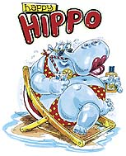 |   Crotchety Camels are weighed down by negative baggage. They can feel  demotivated – and they demotivate others. Although often experienced, they wonder what they can offer and are unable to respond to change and afraid of rejection. They need to be positive, recognise their experience and gain confidence to tackle new challenges.  See below for tips on what to do next  Happy Hippos have lots to offer but are currently too comfortable to change. They like to wallow in their comfort zone and may spend more time planning their annual holiday than their personal and career development. They may only respond to a career crisis and even then probably have no effective plan of action. It's OK to be contented but you still need to consider your long-term plans.  See below for tips on what to do next | 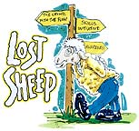  Lost Sheep may lack vital experience, skills or political awareness or fail to have an action plan. Although keen to develop, they often just follow the flock, then wonder why they have ended up where they are and what they have gained from their experiences. They need to make firm career decisions based on research and information.  See below for tips on what to do next  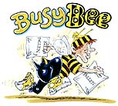 | 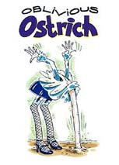  Oblivious Ostriches resist change and ignore their situation. Burying their heads in the sand can mean they fail to see the need to change and miss opportunities. Lack of confidence may be why they take up this position. The first positive step is to lift up their heads and take a good look round.  See below for tips on what to do next  Busy Bees work hard, contribute well and see things through. They have lots of skills but taking on too many tasks at the same time – along with their many other commitments – can lead them to compromise on their career and feel they have not realised their full potential. They may also consider they fail to promote themselves and so risk being passed over for promotion.  See below for tips on what to do next
Legal Disclaimer | © Copyright 2001 Graduate Into Employment Unit

Which animal do you most resemble – why?

………………………………………………………………………………………………………………………………………………………………………………………………………………………………………………………………………………………………………………………………………………………
…………………………………………………………………………………………………………………
…………………………………………………………………………………………………………………
…………………………………………………………………………………………………………………
…………………………………………………………………………………………………………………

What three action points could you now take to improve your career planning skills?

1.

2.

3.

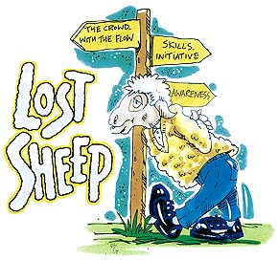
If you're a Lost Sheep
Start by finding a shepherd – somebody you trust who can guide and inform you.
Look at what really motivates you session 2 and audit your transferable skills
Be more proactive in exploring and creating new job and career opportunities.
Get as much relevant experience as possible, do voluntary work etc to gain confidence and use advisory interviews to find out about jobs. Make full use of your existing contacts and don't worry if you have no career focus. Just stay flexible to opportunities as they arise.
Legal Disclaimer | © Copyright 2001 Graduate Into Employment Unit

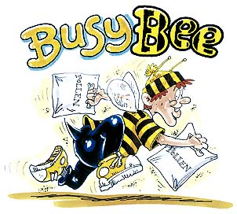
If you're a Busy Bee
Find out where your true commitments lie – is everything you do taking you in the right direction?
Revisit session 2 to learn about your prioritise – do all your tasks add value to you and your job?
Be prepared to compromise in order to get the balance right for you. Celebrate your successes, don't undersell yourself and ensure others don't grab the glory.
Focus on working smarter rather than harder. Understand what employers want You'll find help in session 6. Work in a more structured way and don't let setbacks sap your energy.

Legal Disclaimer | © Copyright 2001 Graduate Into Employment Unit

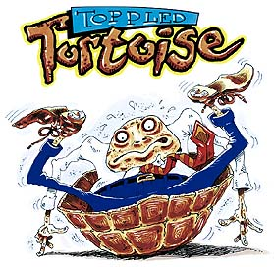
If you're a Toppled Tortoise
Try not to take rejection too personally and don't undersell yourself. Find a helping hand – someone who can boost your confidence and help you gain some structure and direction.
Build your support network – taking control of your career can be a lonely thing.
Try to gradually become more self-reliant by developing your self-awareness, self-confidence and action planning skills. Break your goals into less daunting steps.
Spend time building a picture of where you ideally want to go. Never lose sight of it and keep on going.

Legal Disclaimer | © Copyright 2001 Graduate Into Employment Unit


If you're a Crotchety Camel
Don't undersell your experiences and keep a positive list of achievements and skills. Ensure they appear on your CV.
Find someone to help you review and make use of your past experiences. Focus on solutions not problems and don't dwell on failures. Update your employability skills and be more creative in your career management.
Action Thinking can help with this. It will help you position yourself to seize opportunities when they come along.
Be flexible – you may have to take one or two detours to reach your chosen career.

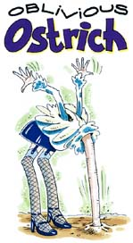
If you're an Oblivious Ostrich
Get your head out of the sand and take an objective look at how you are responding to the changes around you.
Listen and learn from feedback given by others – getting an objective view is essential. Make the most of all the learning, job and career opportunities around you.
Try to gain a greater level of career focus by improving your
self-awareness and opening your eyes to the opportunities
around you.
Are you avoiding things? Ask yourself why. Set regular targets for yourself. Learn to take calculated risks – do not forget the greatest risk of all is inflexibility. Get support from others to help you.

Legal Disclaimer | © Copyright 2001 Graduate Into Employment Unit

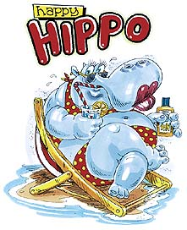
If you're a Happy Hippo
The first thing to do is to be clear on what will make you employable in the future. Keep your employability skills and expertise up-to-date.
Challenge yourself by setting regular personal development targets. It's also time to be honest – are you truly realising your full potential? And are you aware of what you could achieve?
Be more proactive in seeking new opportunities.
Find out where graduates go to – see session 5
Remember also to take time out to think about what makes you happy – ask yourself how you can spend more time doing things you are good at and enjoy.
Find out what you want forma job – see sessions 2 and 4 to help you.
Legal Disclaimer | © Copyright 2001 Graduate Into Employment Unit

Exercise 6

Find your decision-making style

Task

Using the list below try to work out what your decision making style is. You will find the PowerPoint presentation attached to this session will help you do this. You may find it easier to choose one of your examples from Exercise 5 to help you complete this task.

When making a decision, how do you usually go about it?

Impulsive - seizing on a possibility
Emotional – sudden reaction to a new idea
Intuitive – an instinctive reaction to something, what ‘feels’ right
Hesitant - afraid to make a mistake
Avoidant – hoping the need for a decision will go away
Fatalistic – leaving everything to chance
Compliant – conforming to others expectations
Rational – logical appraisal of options available

You can use more than one of these styles
May employ 2/3 of these in the process of arriving at a decision

Would you use different styles for different types of decisions?

Write down your thoughts here:

Exercise 7

Personal Careers Action Plan

Notes
The following is a suggested framework with notes to give you guidance on how to complete a careers action plan.

Begin with a review of where you are now in terms of having a careers idea – ask yourself a few questions to help you decide how far you have come with your career planning and how far you still need to go:

- Do you have more than one idea?
- Remember you can still produce an action plan even if you do not have a clear careers idea – use your Prospects Planner results to help give your action plan a focus.
- What steps do you need to take to help you make up your mind?
- What resources could you use to help you?
- What have you learned from the PowerPoint sessions you have seen?

What are your main objectives? Make these SMART (specific, measurable, with real advantages, realistic and within a set timescale)

On the worksheet below these are described a steps 1, 2 and 3. For each of the steps say:

How you aim to achieve each of these steps by:

- Researching relevant information
- Identifying suitable vacancies
- Finding out which people could help you
- Investigating how the Student Affairs Office and Employability Service can help
- Researching web based materials and other electronic resources such as Prospects Planner and the Windmills website that can help
- Checking how up to date and relevant you feel your CV/Resume is
- Evaluating whether you need to enhance your existing work experience or start to gain work experience
- Considering the skills you feel you need, both personal and technical – how can you improve these?

Finally, consider any obstacles or limitations you feel you may encounter which you will need to solve.

- Are these personal? e.g. family, financial, location
- Are these to do with the availability of opportunities in your chosen career
- Are these to do with the career’s entry requirements – e.g. requirement to possess a certain postgraduate qualification which requires you to pass an entry examination?

The list of possibilities is not complete! There may be other issues you wish to include which are relevant to your situation. Don’t be restricted by the ideas presented above – these are a guide to get you started.

Finally, include a conclusion which summarises the key issues presented to you during this employability skills package and completion of the worksheets. Include an outline of your next steps which will be a discussion of the general activities you need to do and any plans you have.

THE CAREERS ACTION PLAN

Review – where you are now

Step One:

Date(s) to be done by:

Step Two:

Date(s) to be done by:

\

Step Three:

Date(s) to be done by:

Conclusion

